1. Basics of Excel spreadsheet, reading data into Excel: regular excel format, text format Data manipulation in Excel: Format cells, hide and unhide columns, sort one column and multiple column data set using Excel.

Spreadsheet is made up of columns and rows. A, B…. are columns and 1, 2, 3…. are rows.

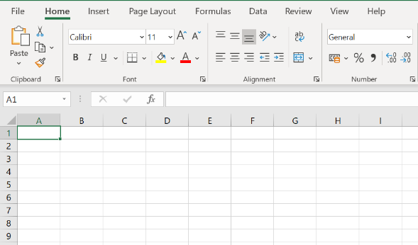

Reading data into excel

The data is generally represented as a regular excel file or is represented as a text file, where the text is delimited either by a comma, a tab or a space. The data is represented in following ways:

* Regular Excel format (.xlsx, .xls)
* Text format (.txt) -> This is further divided into three types
* Comma separated
* Tab delimited
* Fixed width

- Now let us perform an example for understanding

-Let us insert an storesales.txt into excel

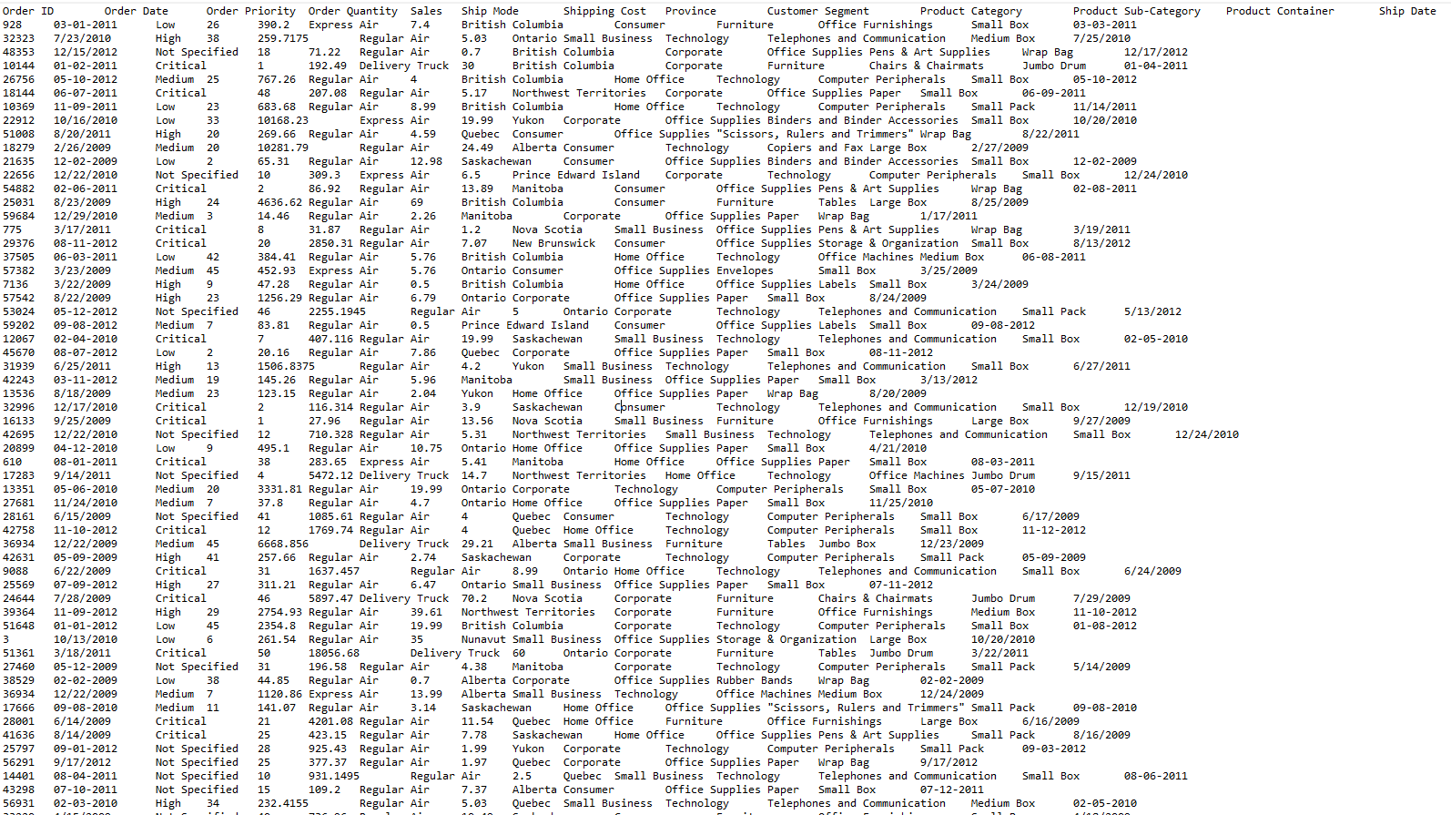

1. Open excel file
2. Click on files and click open
3. Select the text file that needs to be inserted in the excel
4. Then a tab open select delimited as our data is tab separated.

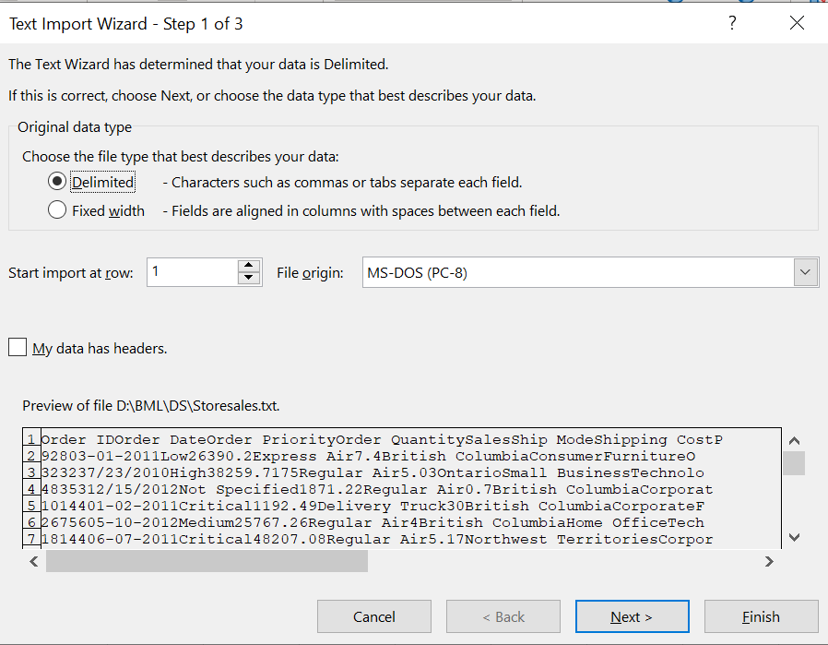

1. Click on next then you will find this select the following options relevant to the data we selected tab because the data is in tab format. Then click on finish.

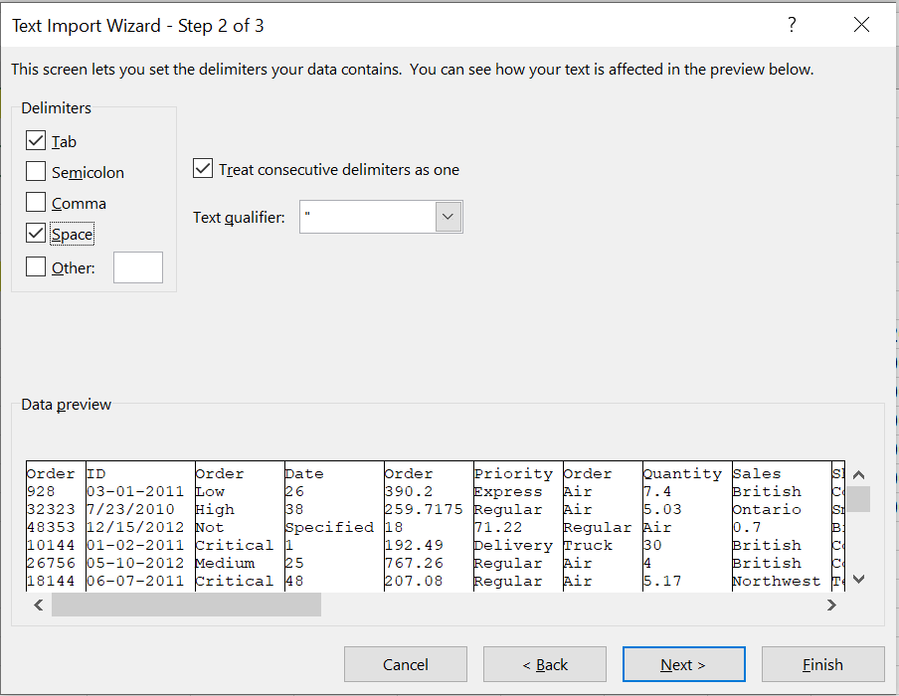

The Result

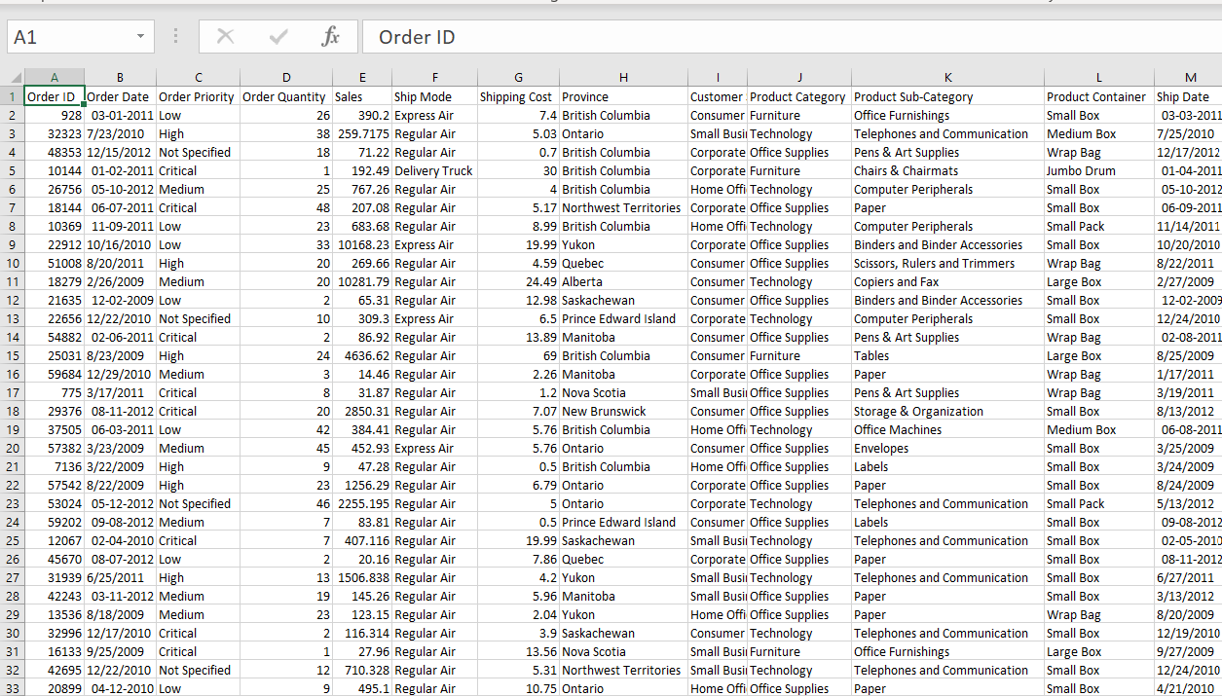

Basics of data manipulation

If we want to know that how many rows are there in column then select the respective cell and press control + down.

Some sales values have decimal point greater than 2 then how to change the values of sales data of decimal points 2?

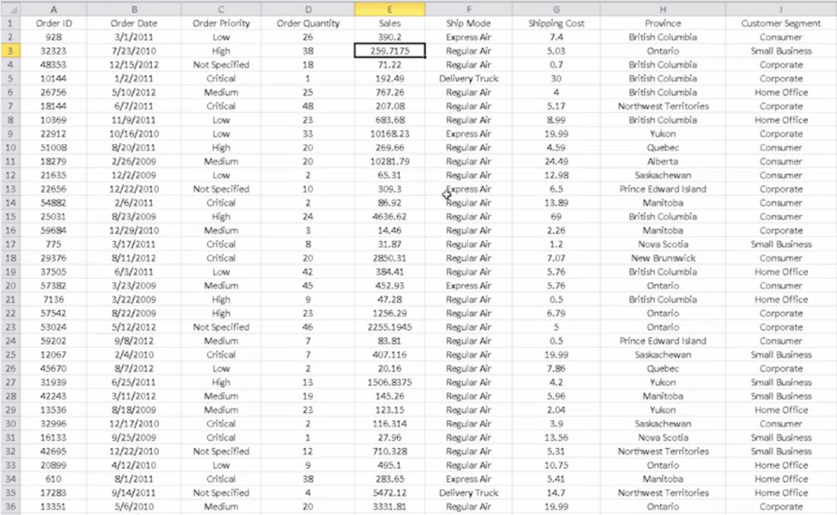

1. Select whole E column and Left click on the selected table and select format cell.

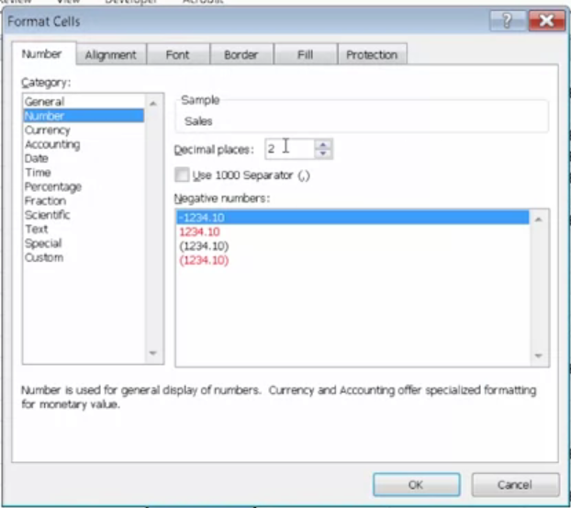

1. Select the number option and change the Decimal place to the desired value according to the question we change the value to 2. For getting the sales value with two decimal value.
2. Result is sales with 2 decimal places.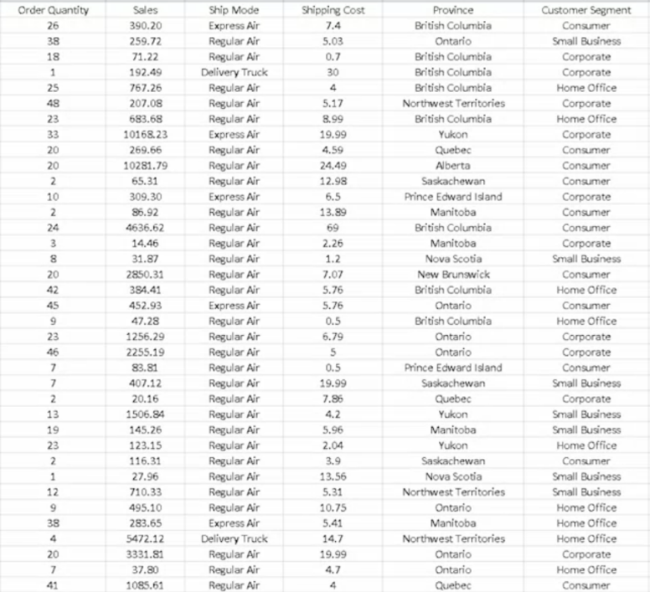

Sorting the data according to the year and decreasing order of sales amount.

1. First, select the whole data by selecting the first cell and pressing Shift+control+right+down.
2. Click on data, then on sort.
3. 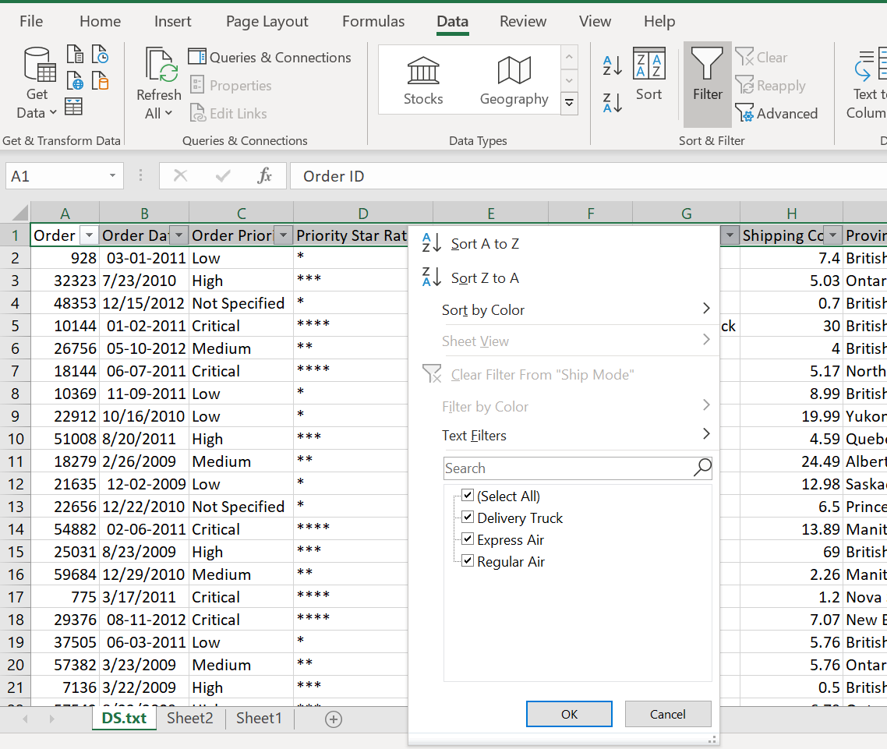

SUM – Used to calculate the total value like,   
1. Select the input cell  
2. Type =sum(   
3. Select the range for the value  
4. Click enter

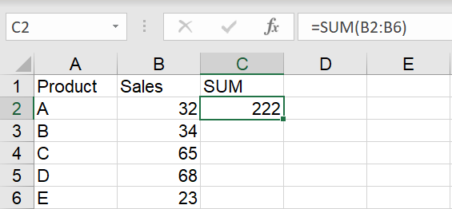

SUMIF – adds the values based on conditions

1. Select the input cell  
2. Type =sumif(   
3. Select the range for the value, give comma and condition in “ ”.  
4. Click enter

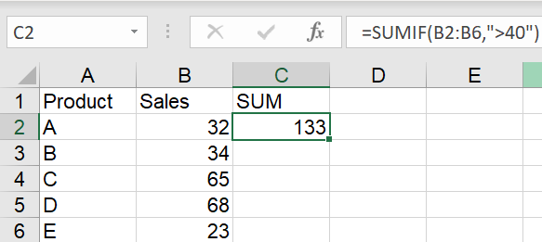

AVERAGE – sum of given values by total number of values selected.

1. Select the input cell  
2. Type =average(   
3. Select the range for the value  
4. Click enter

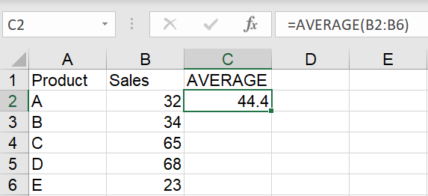

COUNT – counting the number of cells in a column

1. Select the input cell  
2. Type =count(   
3. Select the range for the value  
4. Click enter

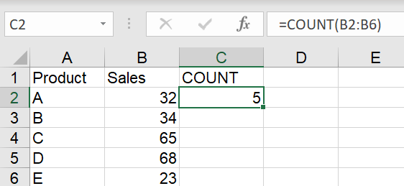

COUNTIF – counting the eligible number based on the condition

1. Select the input cell  
2. Type =countif(   
3. Select the range for the value  
4. Click enter

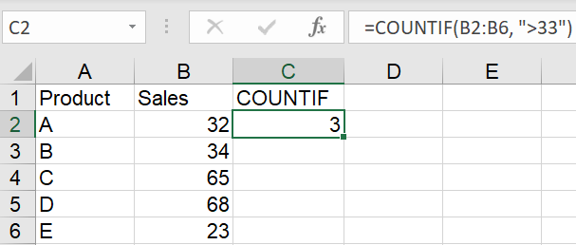

MAX – used for finding maximum value in data

1. Select the input cell  
2. Type =max(   
3. Select the range for the value  
4. Click enter

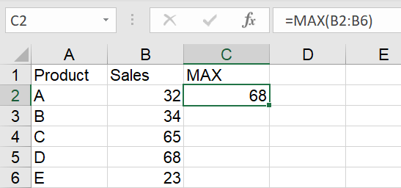

MIN - used for finding minimum value in data

1. Select the input cell  
2. Type =min(   
3. Select the range for the value  
4. Click enter

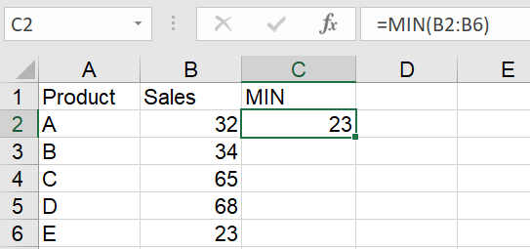

POWER – Multiplying the same value by itself in a defined count of number.

1. Select the input cell  
2. Type =power(   
3. Select the range for the value  
4. Click enter

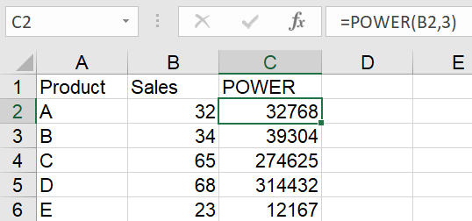

Here the sales is multiplied thrice by itself

IF – Applying simply condition to get the desired data

1. Select the cell
2. Type =if(c2=”critical”,”****”,”*”)
3. This will give the result **** if it is critical, * if not critical.

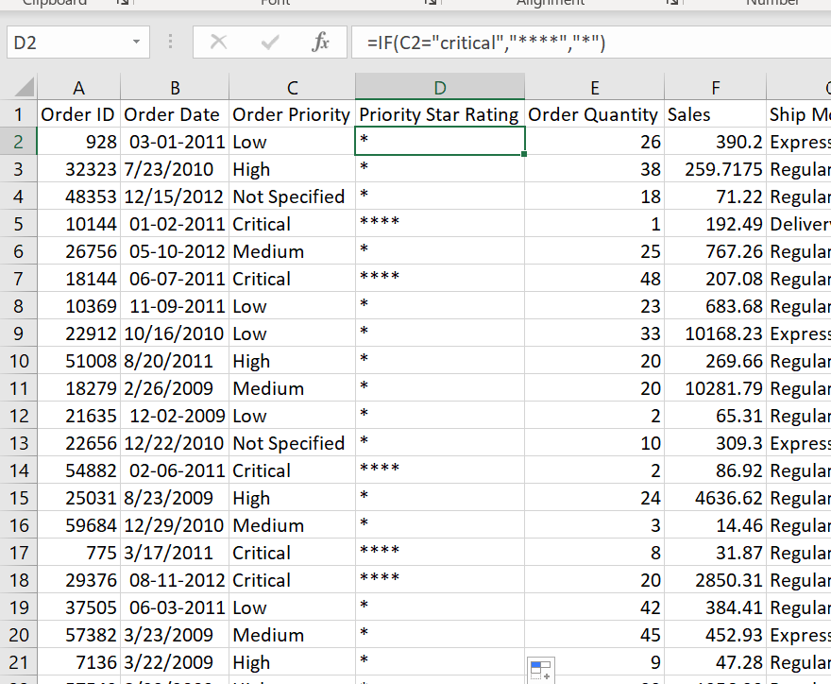

NESTED IF – Applying complex condition to get the desired data.

1. Analysing the given condition
2. Critical gets ****, medium gets ** and high gets *** and if it doesn’t satisfy any of this condition then *.

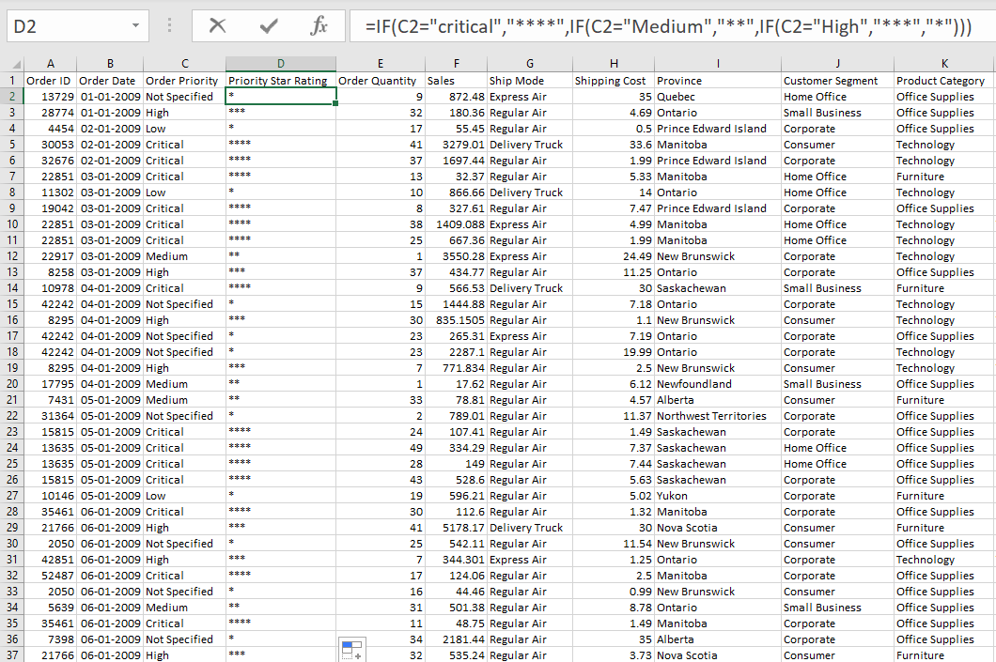

VLOOKUP –

1. Select the cell where VLOOKUP needs to be added.
2. Relevant to situation we are adding the full names of the cities beside their short name.
3. The sheet 2 must contain the data relevant to the condition
4. 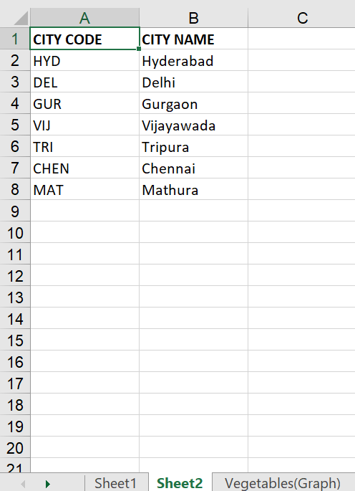
5. In sheet 1 select M2 and type =vlookup(L2,sheet2!$A$2:$B$8,2,FALSE)

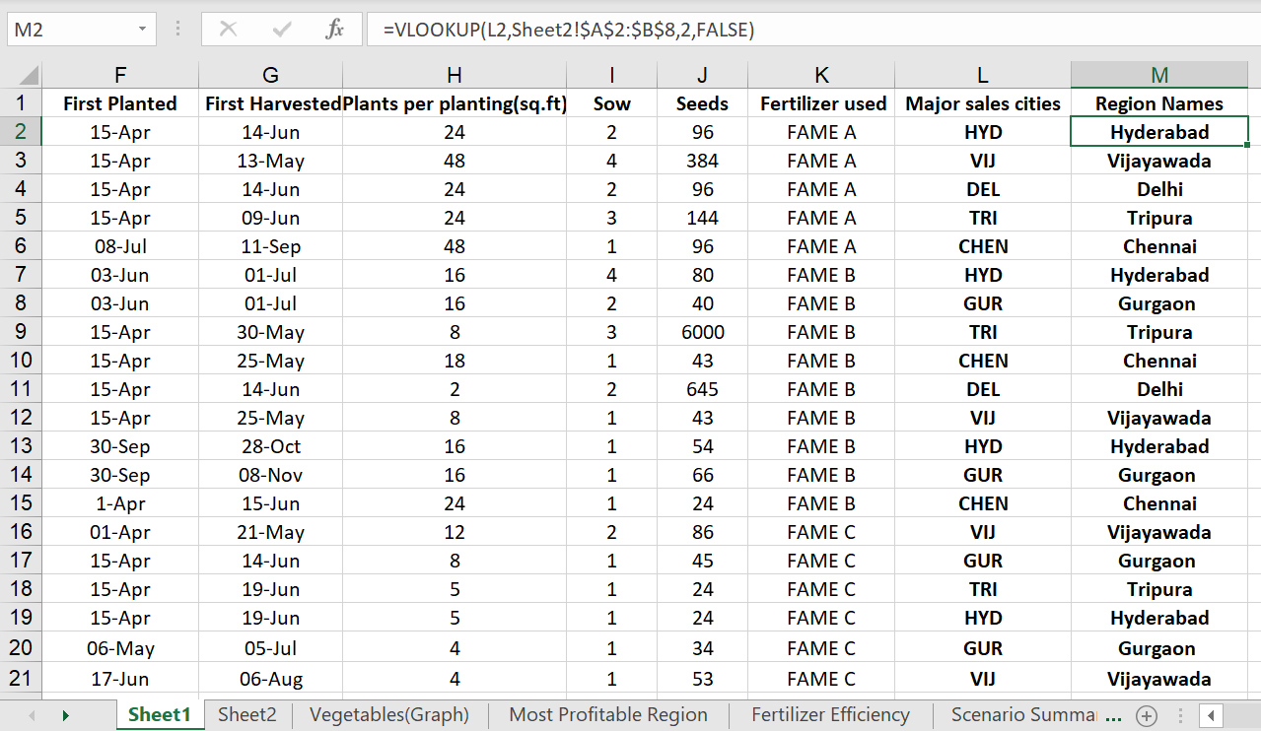

WHATIF ANALYSIS – Consider the given data.

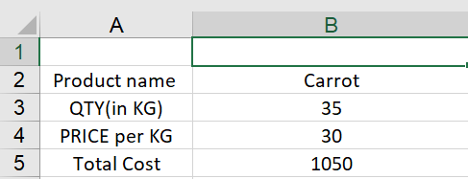

Here the total cost is represented in B5 by formula “=B3*B4” or B5 is =B3*B4

1. Click on data and click on what if analysis.
2. We find three cases they are: - Scenario manager, Goal seek, Data table
3. Let’s start with goal seek
4. After clicking on Goal seek

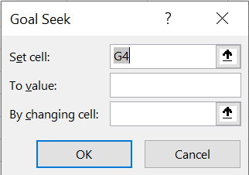

1. Select the [by changing cell] value which is not constant can be updated whenever needed and speed up the calculation process.
2. Updatable value need to be entered in [To value]
3. Cell containing formula need to be selected in [set cell].

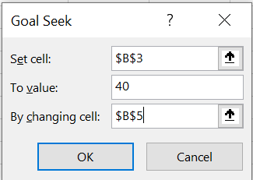

1. Now we will get the data on the quantity of carrot we get for 40 rupees for 30 kgs.

RESULT

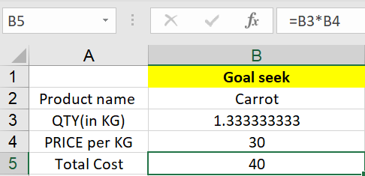

Data Table  
 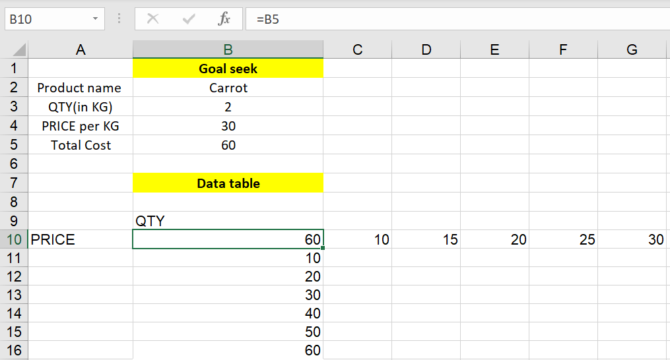

Consider a situation where we want to know the prices of carrot 🥕 under interested quantities then.

1. 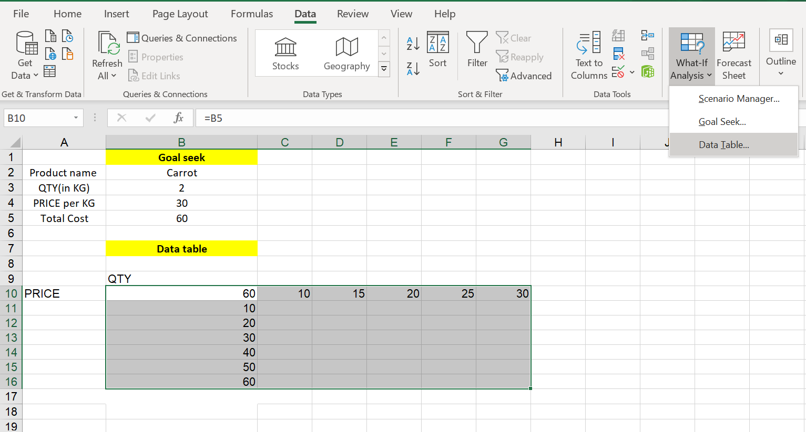

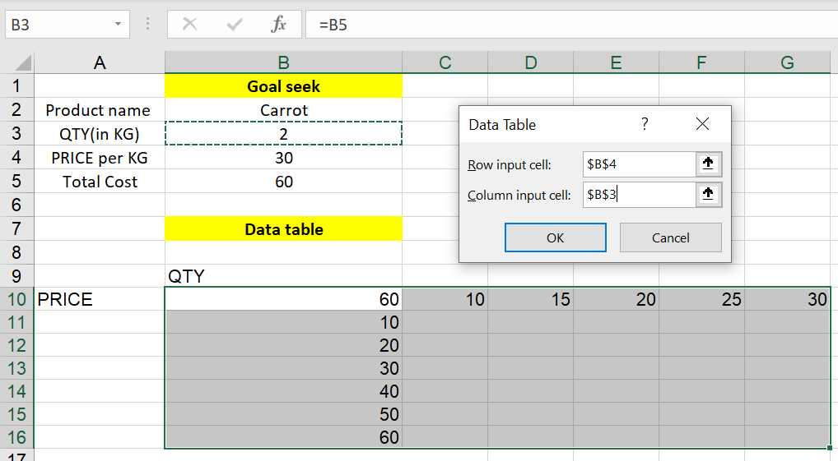

RESULT

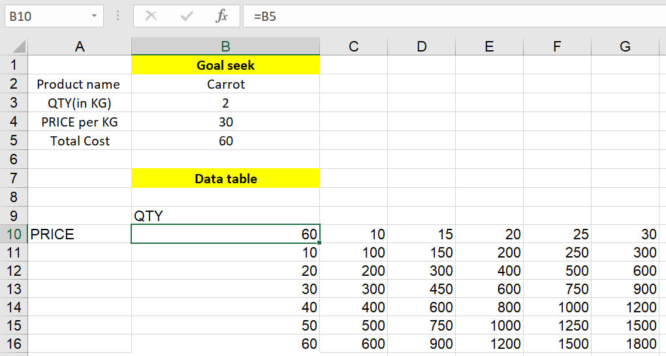

Scenario Manager

1. Select data and click on what if analysis
2. Select scenario manager.
3. Add the scenario relevant to data
4. According to our data we are adding the situation for 2020, 2021, 2022, 2023, 2024 and 2025.
5. Click on summary to get the scenario summary in the next sheet.

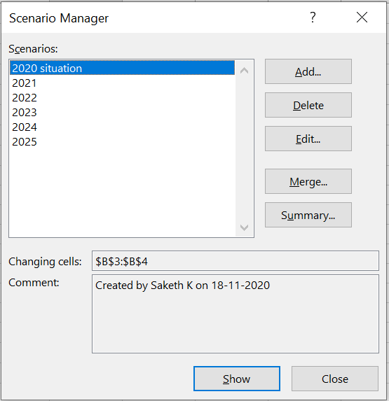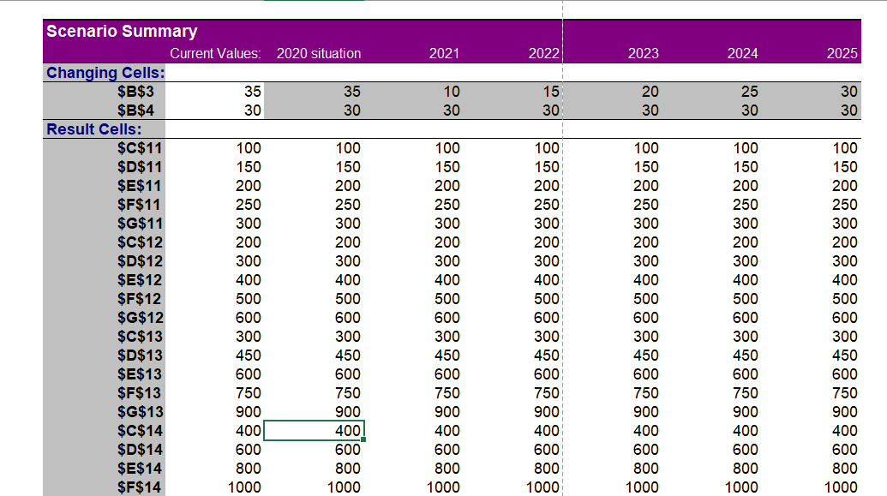

Pivot table in excel

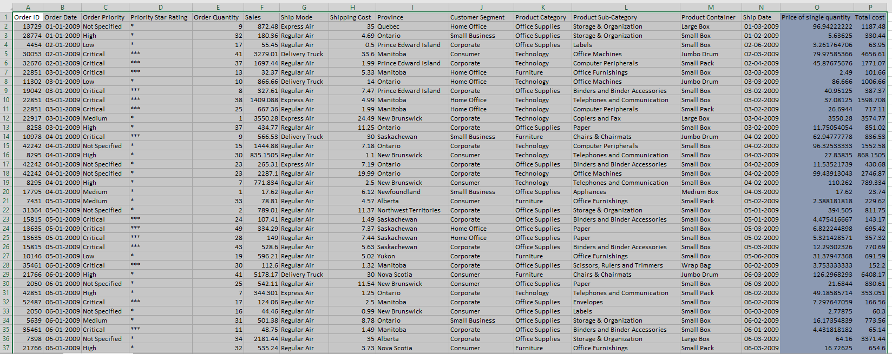

1. Select the whole data
2. Click on insert and select pivot table
3. Click on ok

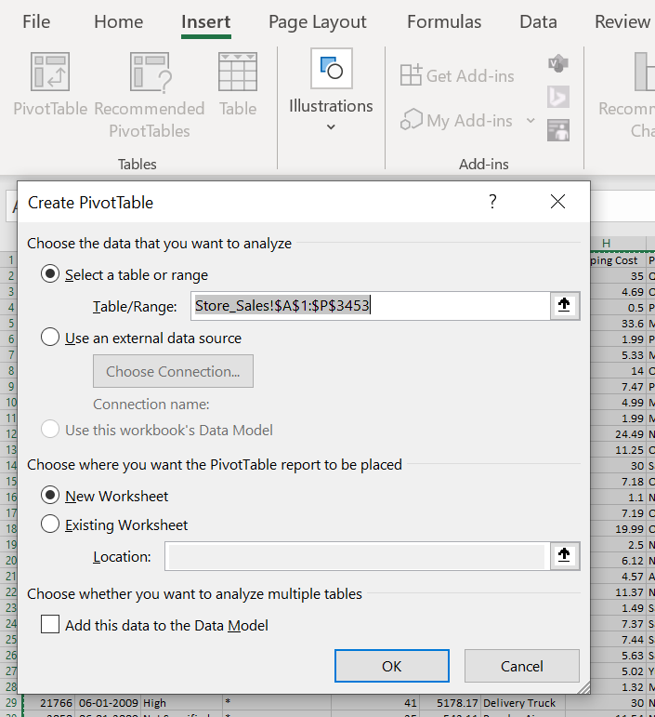

1. Add the provinces in columns
2. Add year and order date to rows
3. Add the sum of sales in values.

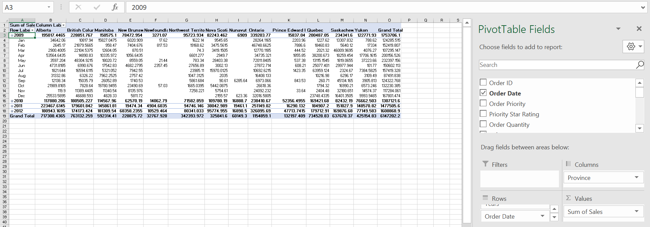

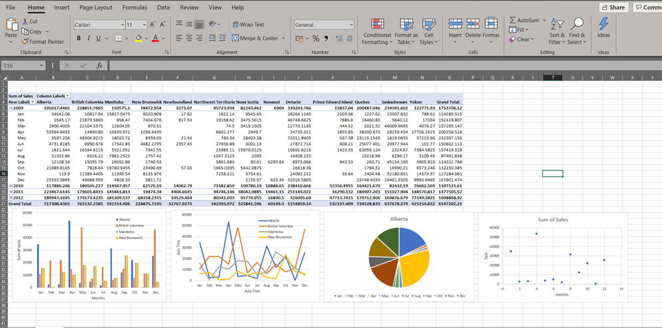

1. From the data we can create the **(Bar/Line/Pie/Scatter graphing):**
2. Insert🡪 Charts (Bar/Line/Pie/Scatter)
3. Right click on the graph🡪select data
4. Insert the levels🡪
5. Enter the columns and the row in levels 🡪click “Enter”.

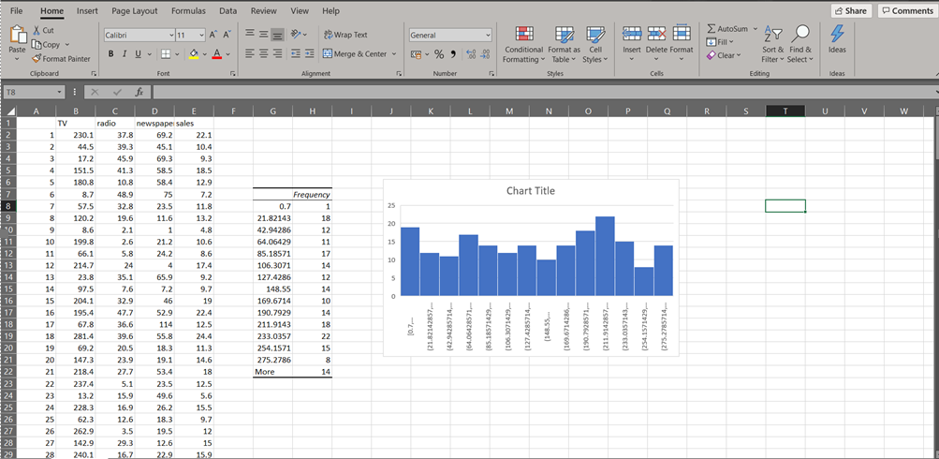

Regression

1. Add the regression to the following data given below.

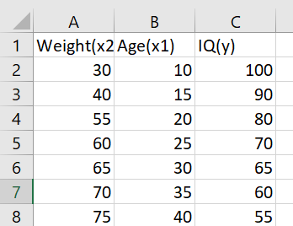

1. Select data and select data analysis option
2. Select regression

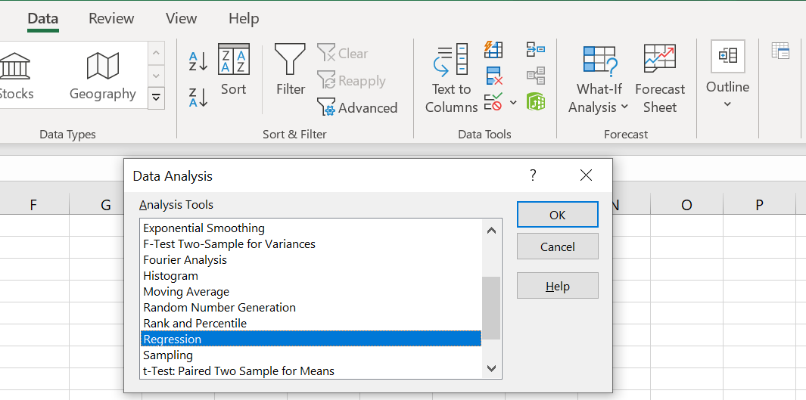

1. Select the data as shown below.

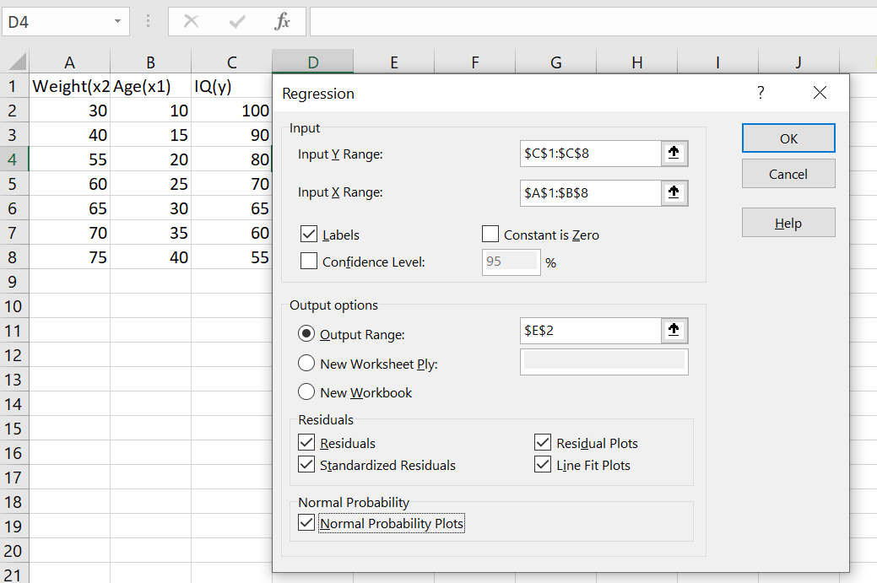

1. The residual and normal probability adds the graph to the data.

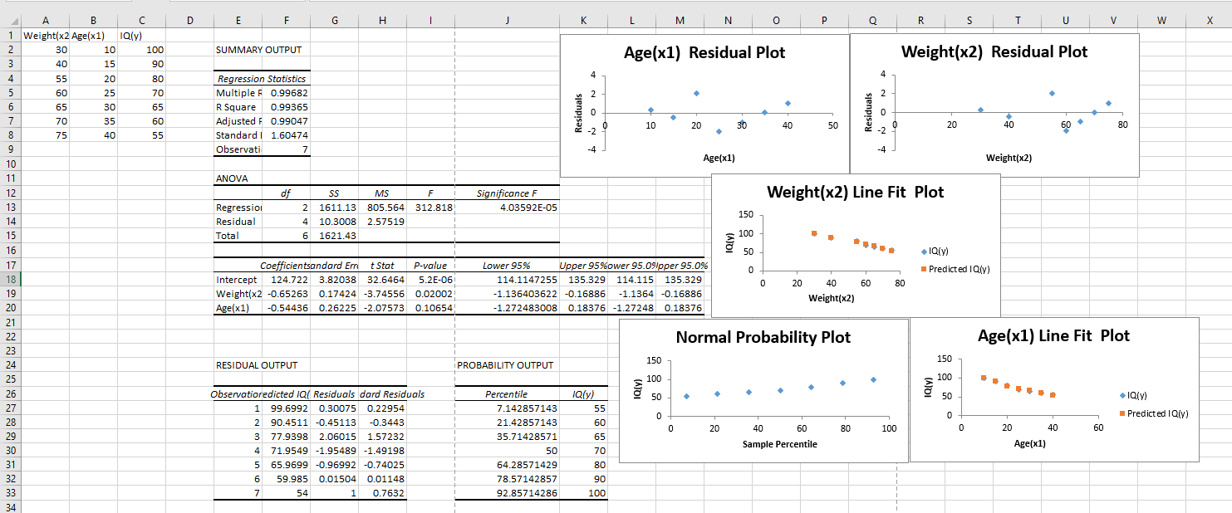

**Steps (Regression Analysis):**

1. Select Data and click Data analysis
2. Regression and select the independent and dependent values in input Y range and input X range
3. If it has labels selected then click on Labels, if you want in new sheet the click on new sheet and if wanted any more information about regression model click on below options
4. click enter(OK).

By above information, we can check the regression model explains about independent and dependent variables correct or not.

**R Square**. It is the coefficient of determination which is used as an indicator of the goodness of fit. It shows how many points fall on the regression line. How much near to 1 that much good is the regression model.

The most useful component in this section is **Coefficients**. It enables you to build a [linear regression equation](https://www.ablebits.com/office-addins-blog/2018/08/01/linear-regression-analysis-excel/#linear-regression-equation) in Excel:

{Y= m(X)+C**}**

For our data set, where *y* is the IQ, x1 is age and x2 is weight, our linear regression formula goes as follows:

{IQ= -0.652*weight + age *(-0.544) +124.722}

And about error will be said by **Standard error**